**DBMS SKILL-6**

**PRELAB**

1. How to use Auto Increment in SQL?

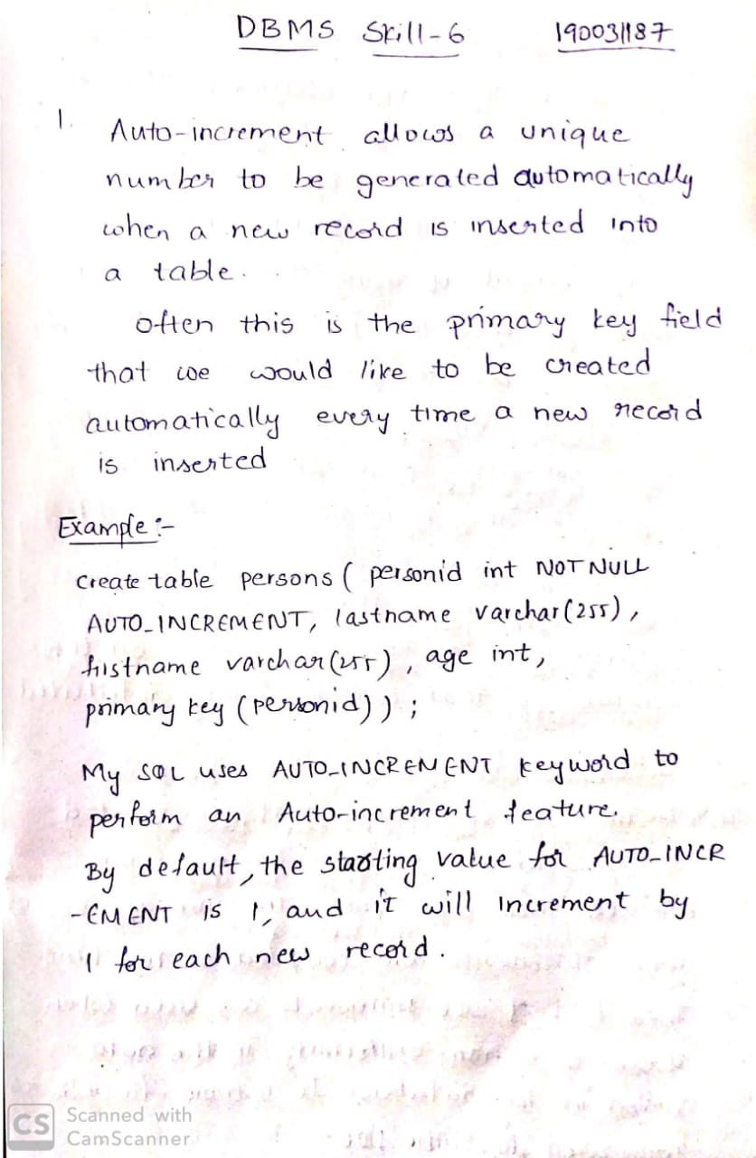

1. What is embedded and dynamic SQL?

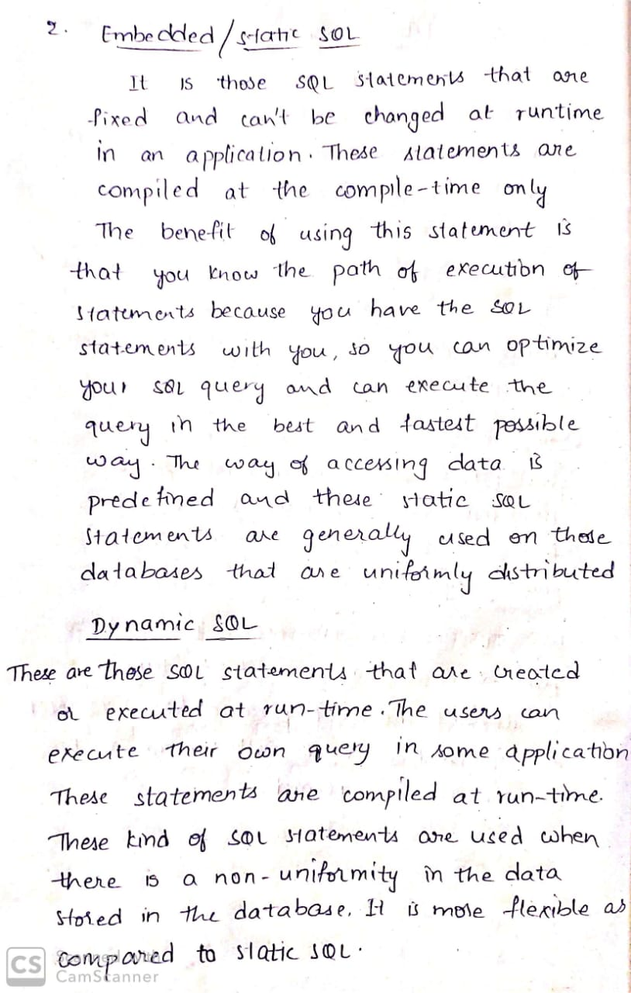

1. What is meant by ALIAS in SQL?

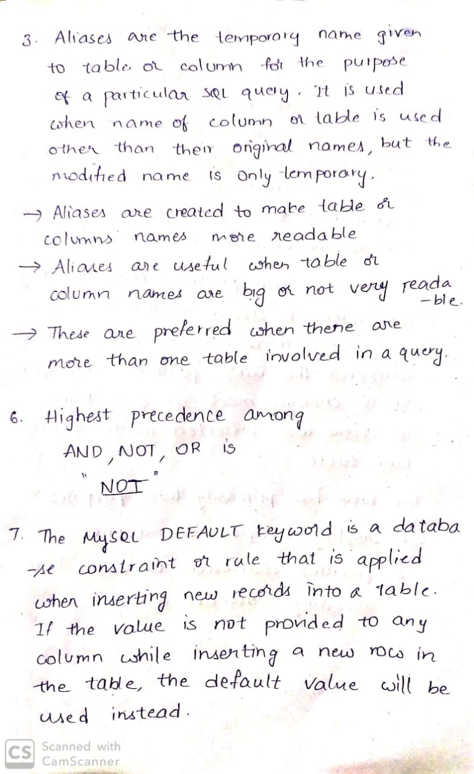

1. Which operator has the highest precedence among the following − AND, NOT, OR?



1. While executing certain commands Mr.Jack is confused to decide whether View is a logical storage or physical storage. State him an appropriate solution with a valid reason?

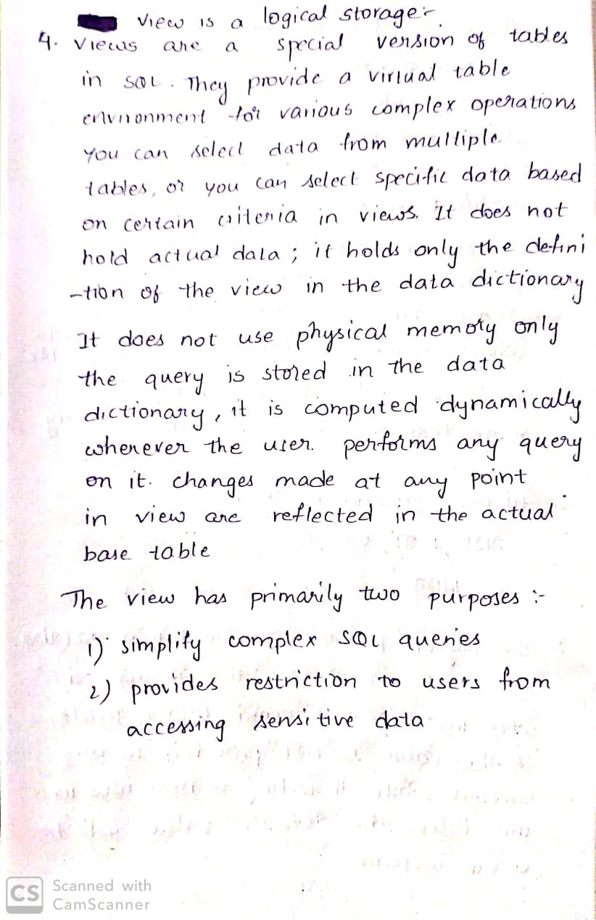

1. How to build authentication to a database?

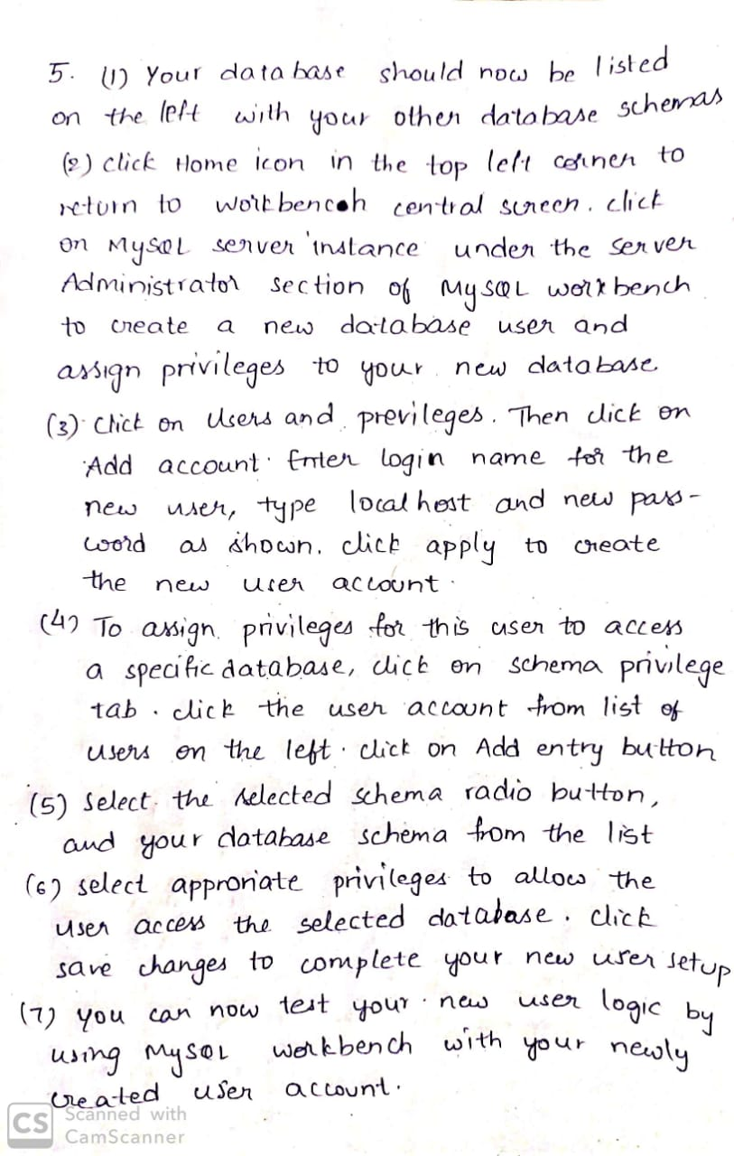

1. What is DEFAULT?



**INLAB**

Implement SQL Queries on Case Study 8 (**SAINT GOBAIN)**

**QUOTATION:**

|  |  |  |  |  |  |  |  |  |  |
| --- | --- | --- | --- | --- | --- | --- | --- | --- | --- |
| Cust  _ID | Cust_Na me | Cust_Phone | Glass_ Type | Glass_ thick | Glass_ Measure | Glass_ color | Address | Exp_ Amt | Advance_ Paid |
| 1 | Raju | 8767895698 | Clear glass | 4MM | 140CM | Black | Hyd | 10000 | 2000 |
| 2 | Hari | 9999887766 | Mirror | 5MM | 150CM | Blue | Delhi | 11000 | 2500 |
| 3 | Arun | 7567896546 | Clear glass | 6MM | 120CM | Black | Mumbai | 9000 | 1000 |
| 4 | Kiran | 6754567890 | Mirror | 3MM | 200CM | Blue | Hyd | 20000 | 5000 |
| 5 | Chand | 7164567897 | Mirror | 4MM | 120CM | Blue | Hyd | 15000 | 6000 |

**BILL:**

|  |  |  |  |  |  |
| --- | --- | --- | --- | --- | --- |
| Bill_ID | Cust_Name | Cust_Phone | Address | Glass_Feature | Mode_Pay |
| 100 | Raju | 8767895698 | Hyd | Good | Cash |
| 101 | Hari | 9999887766 | Delhi | Good | Credit |
| 102 | Arun | 7567896546 | Mumbai | Good | Cash |
| 103 | Kiran | 6754567890 | Hyd | Good | Cash |
| 104 | Chand | 7164567897 | Hyd | Good | Cash |

1. Create tables with the required constraints for the given case study

QUOTATION

create table quotation(cust_id int primary key,cust_name varchar(30),cust_phone bigint,glass_type varchar(30),glass_thick varchar(10),glass_measure varchar(10),glass_color varchar(10),address varchar(50),exp_amt int,advance_paid int);

BILL

create table bill(bill_id int primary key,cust_name varchar(30),cust_phone bigint,

address varchar(50),glass_feature varchar(20),mode_pay varchar(20));

1. Insert 10 records into the created tables

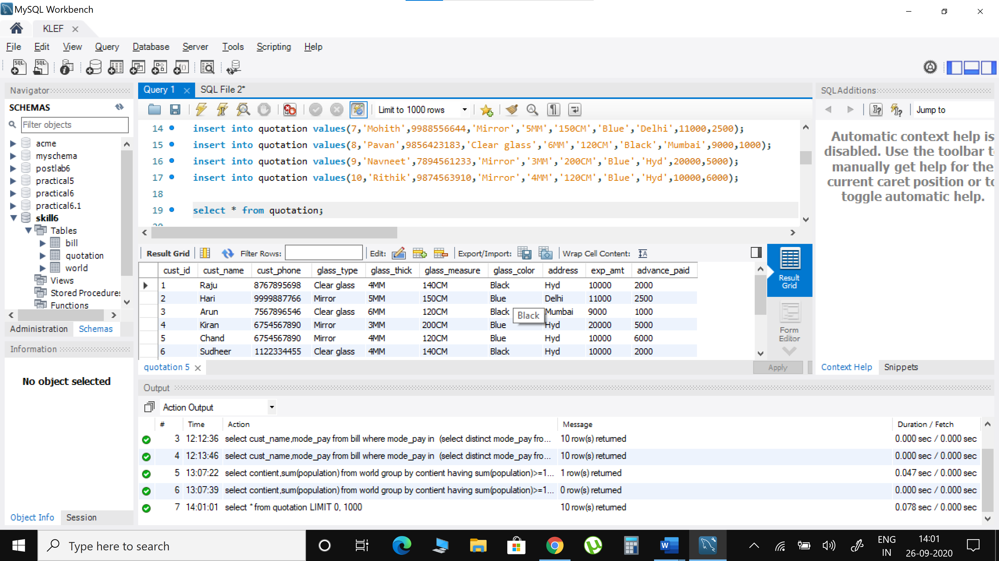

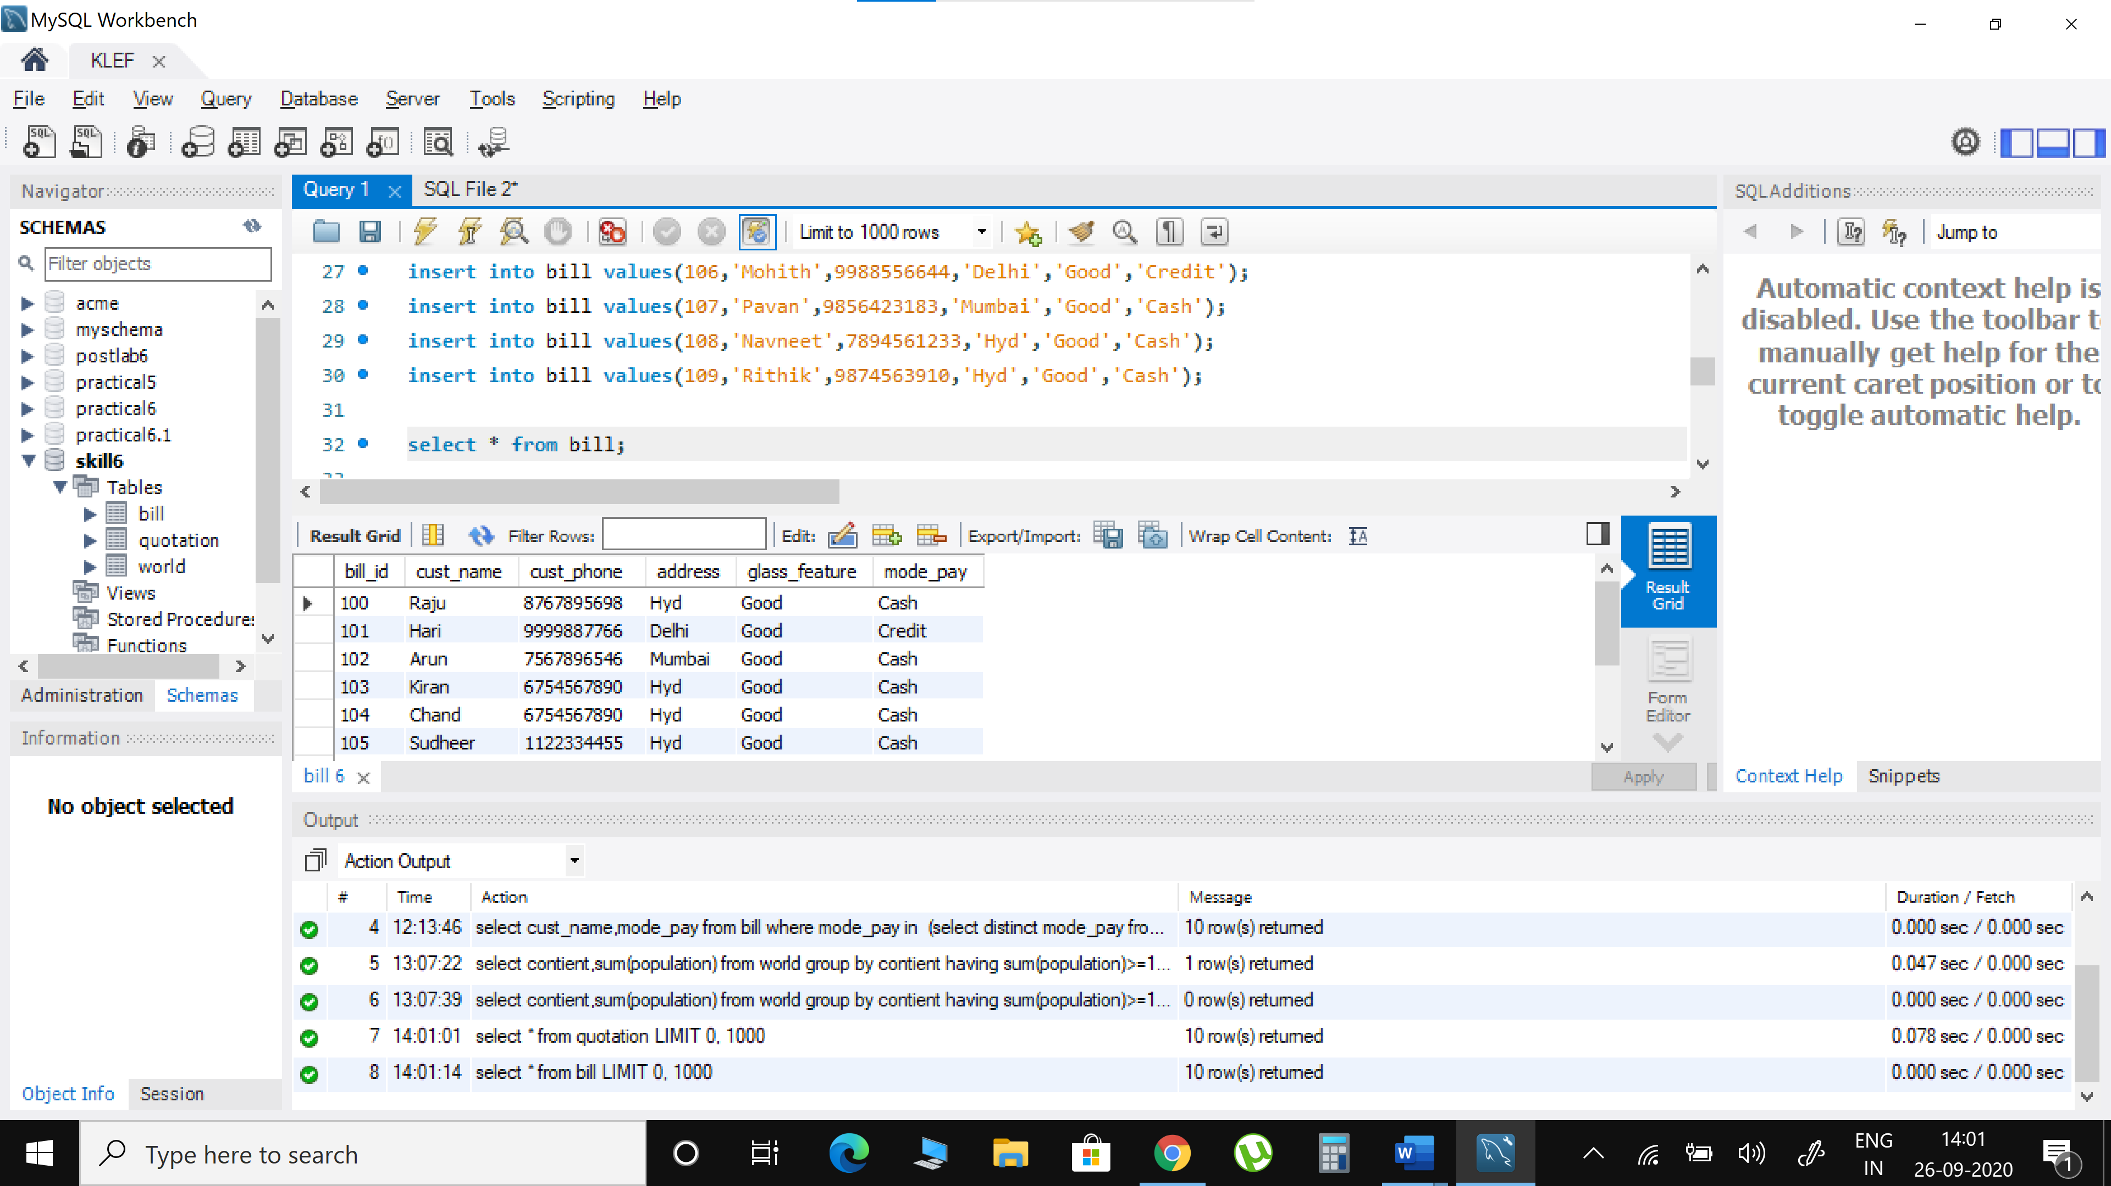

1. Write a SQL query to find out Customer ID and Customer Name in ascending order.

select * from quotation order by cust_name,cust_id asc;

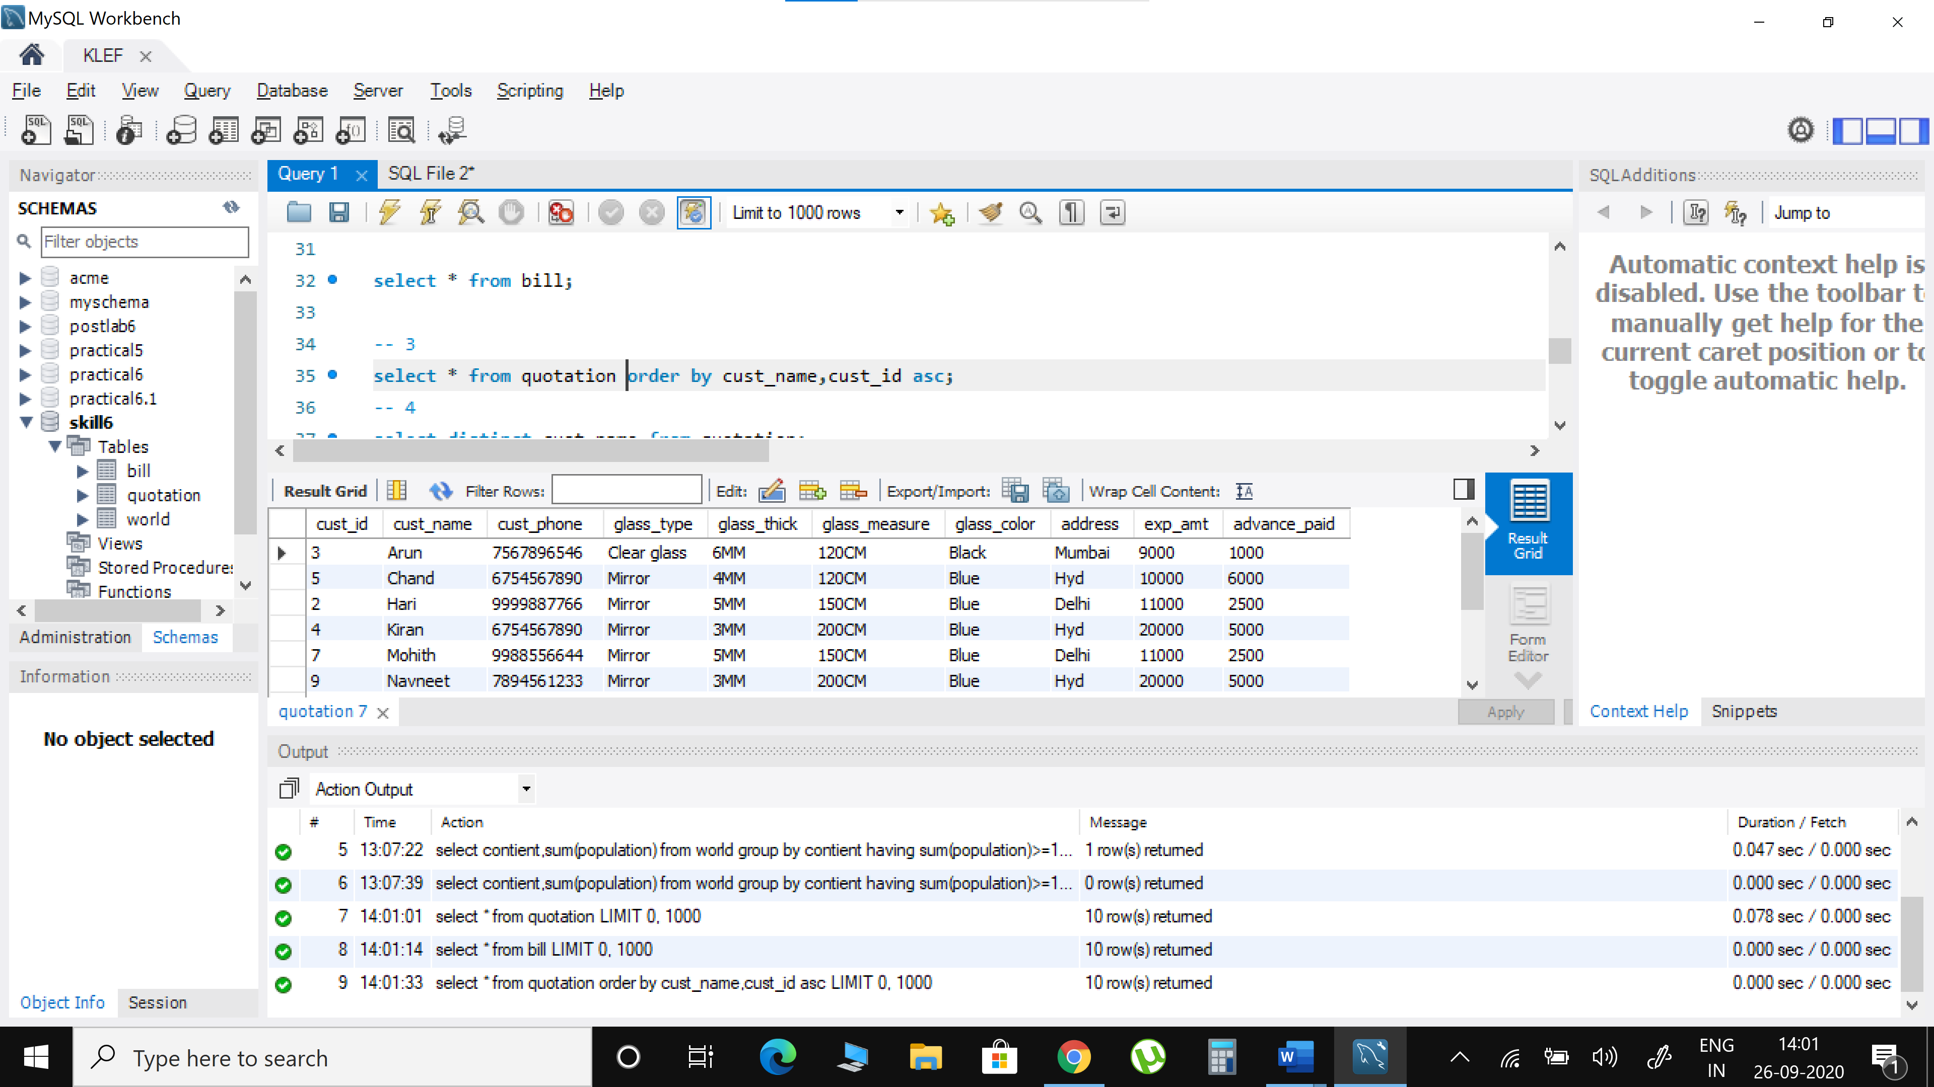

1. Find unique Customer Name in the Quotation table.

select distinct cust_name from quotation;

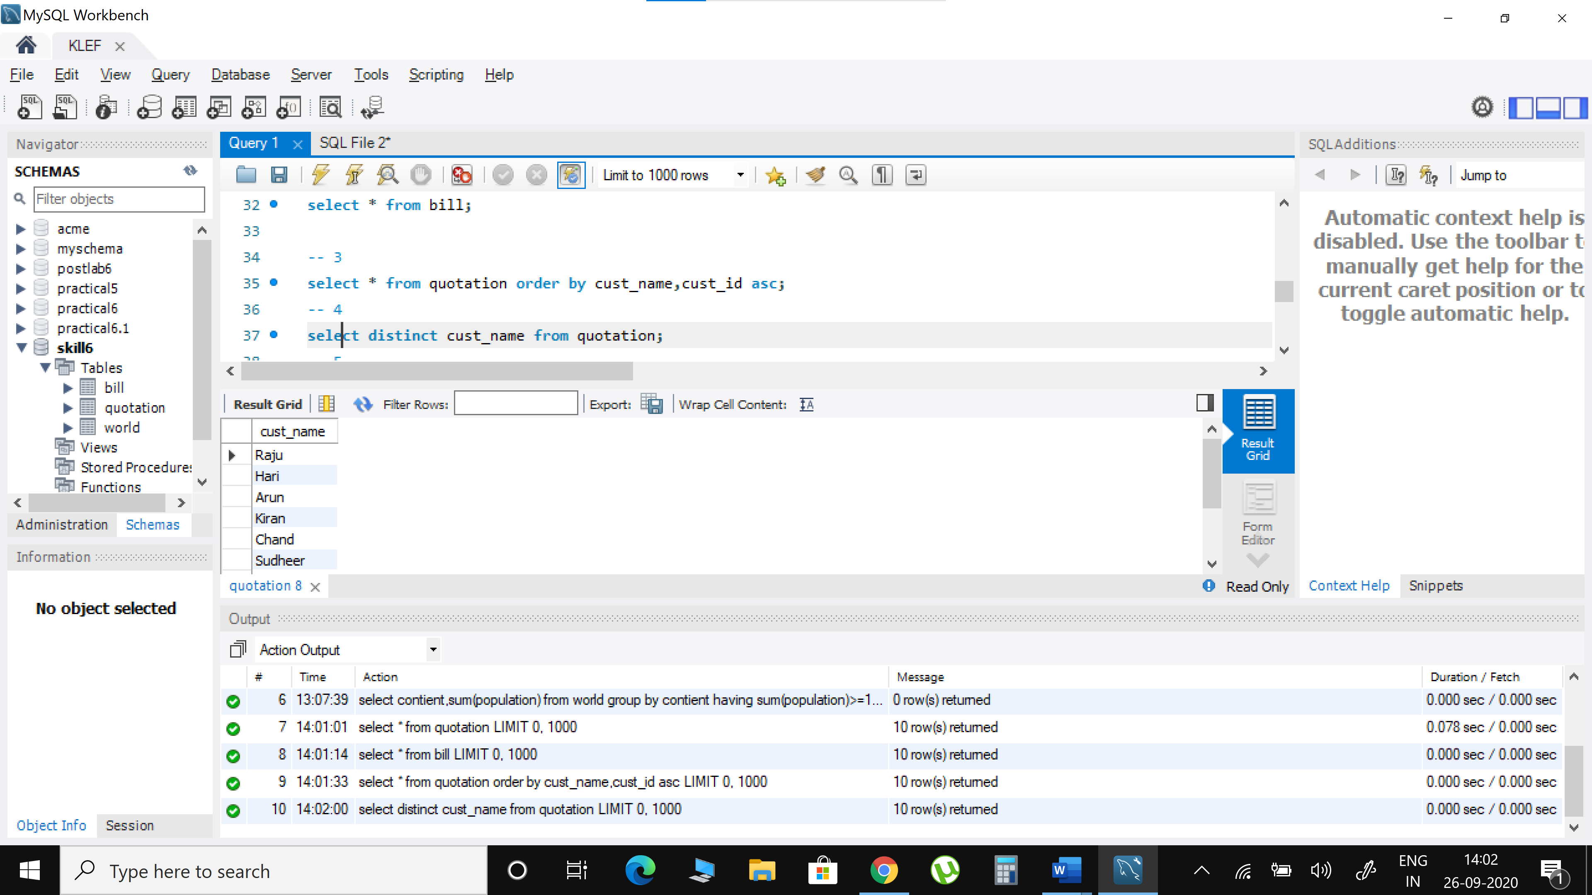

1. SQL query to find the Glass Thickness where number of Customer of highest thickness.
2. Write a SQL query to find out the amount has to paid by the customer in Quotation Table.

select cust_name,exp_amt-advance_paid as amt_to_be_paid from quotation;

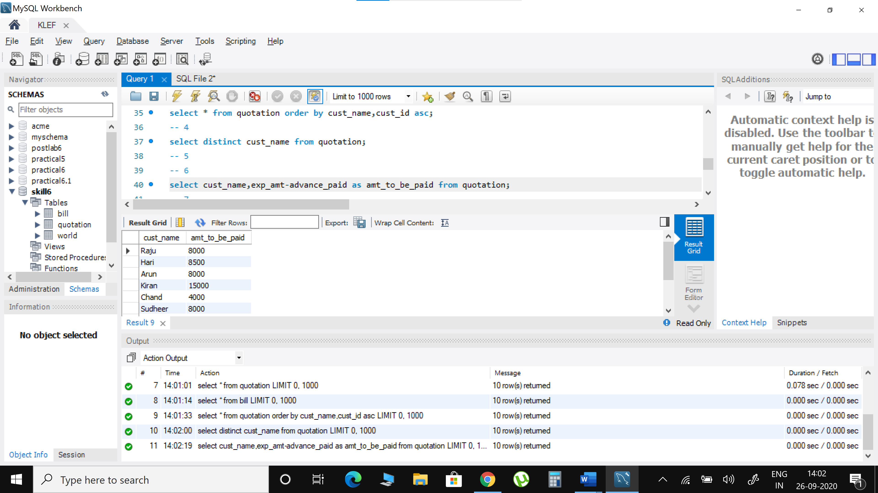

1. Write a SQL query to list the name of those whose name starts with ‘A’ in Quotation Table.

select * from quotation where cust_name like 'A%';

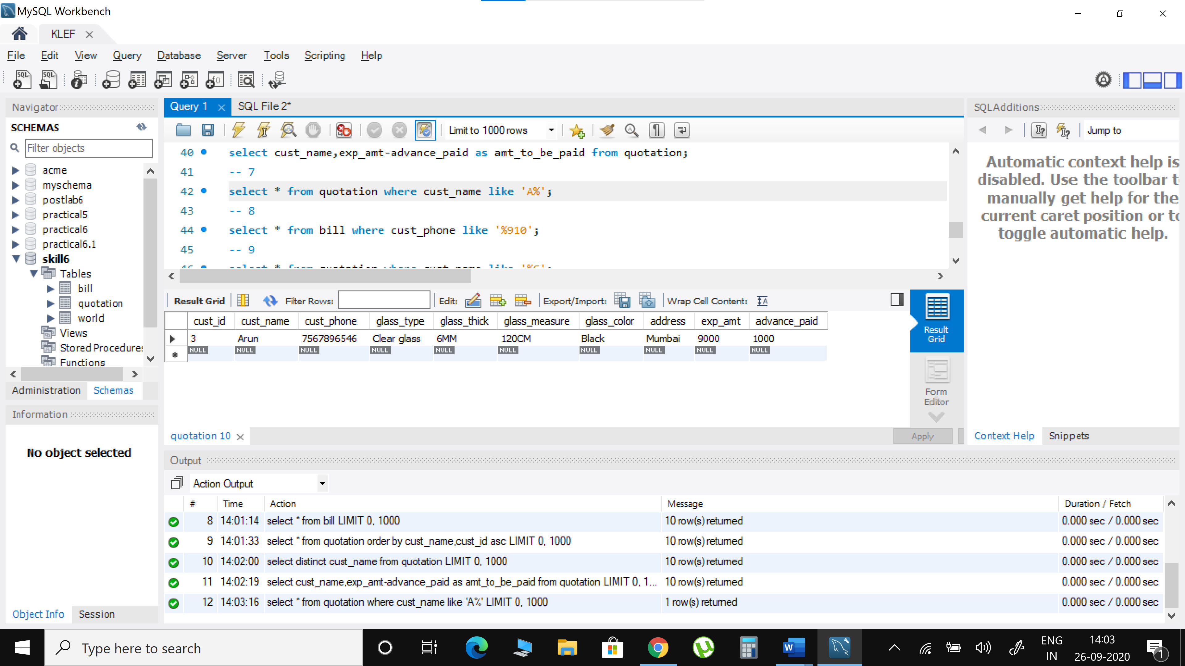

1. Write a SQL query to list the Phone no. that ends with “910” in the Bill table.

select * from bill where cust_phone like '%910';

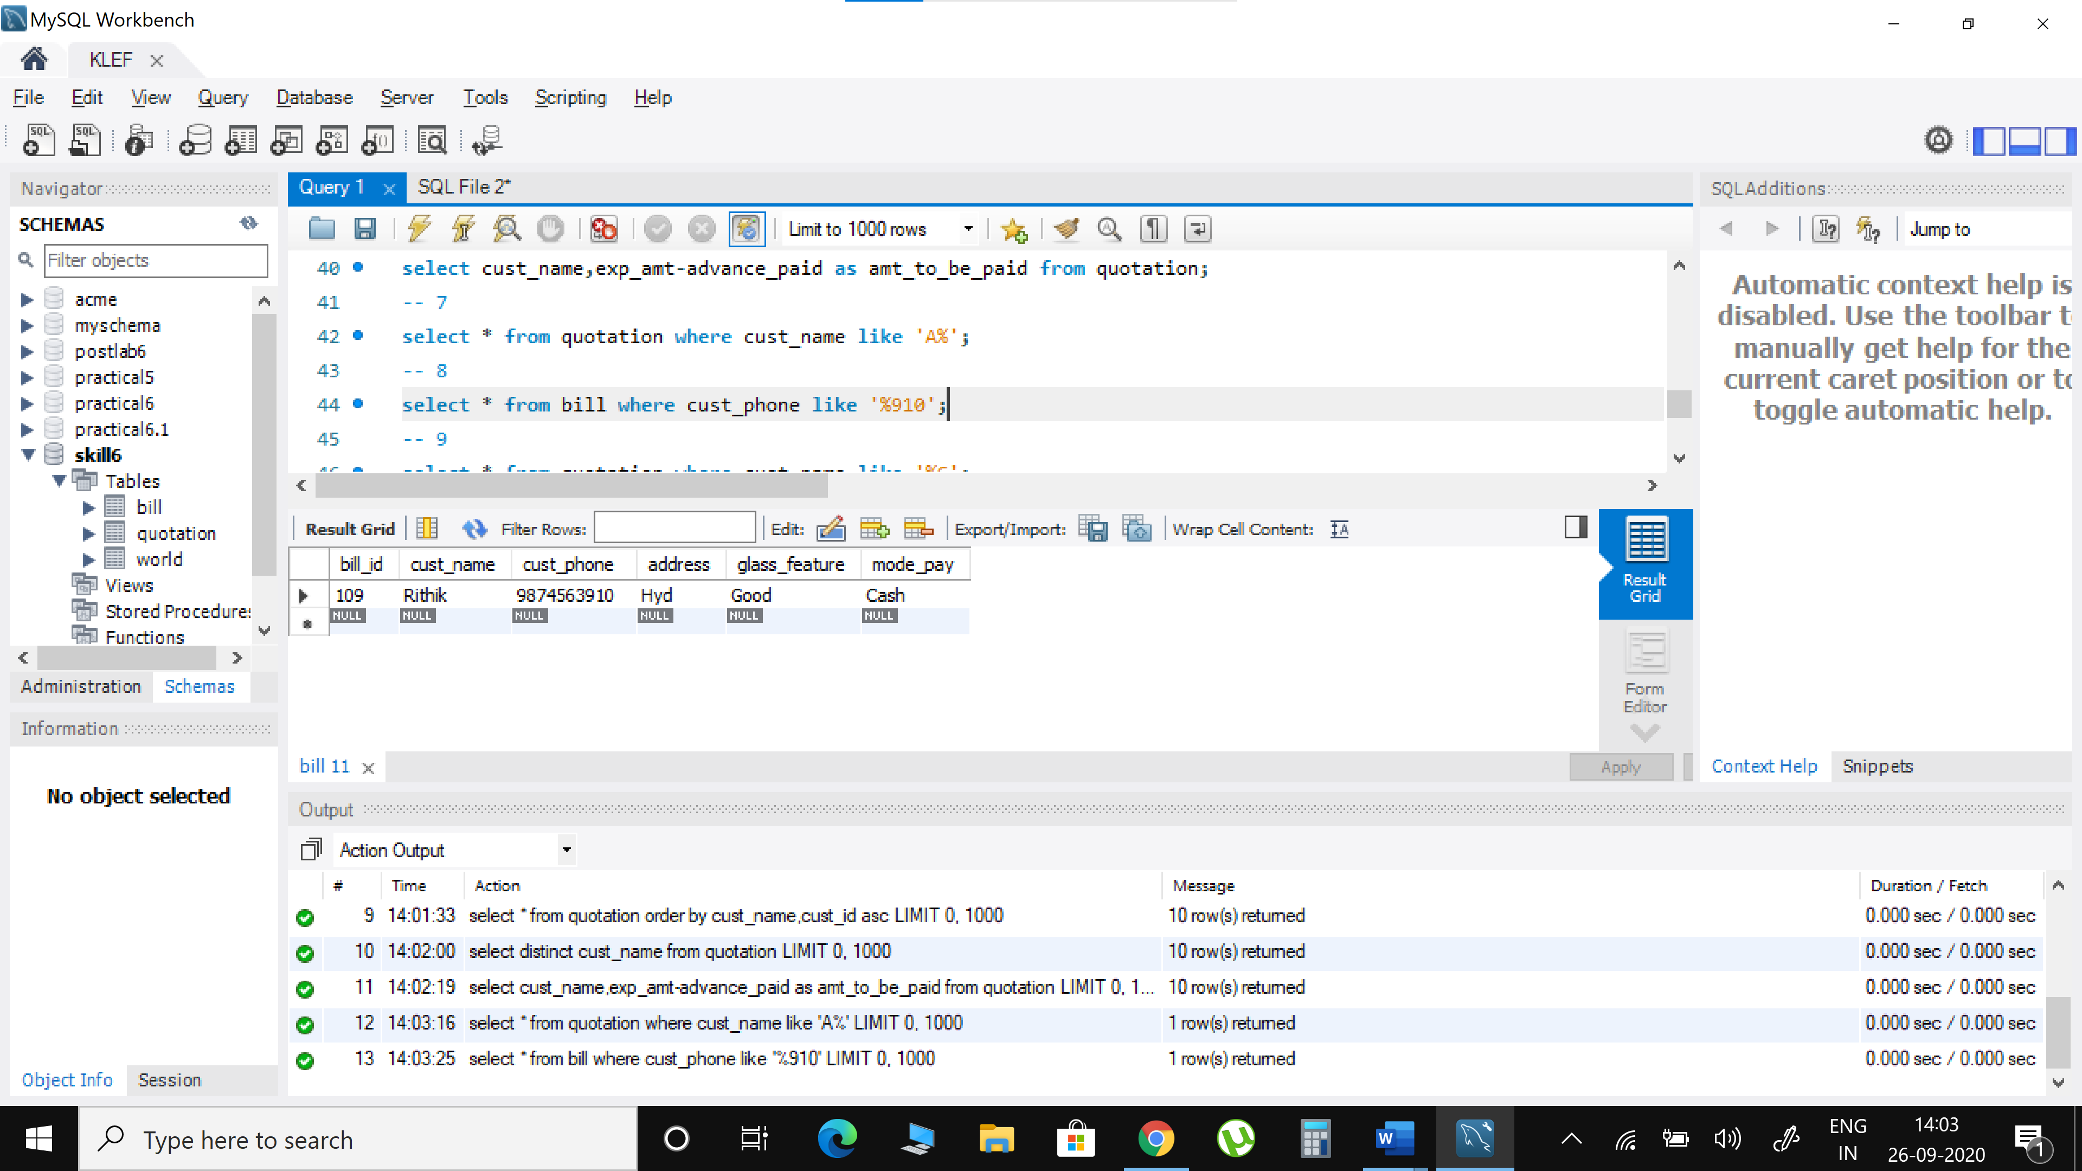

1. Write an SQL query to print details of the Customer whose Name ends with ‘C’

select * from quotation where cust_name like '%C';

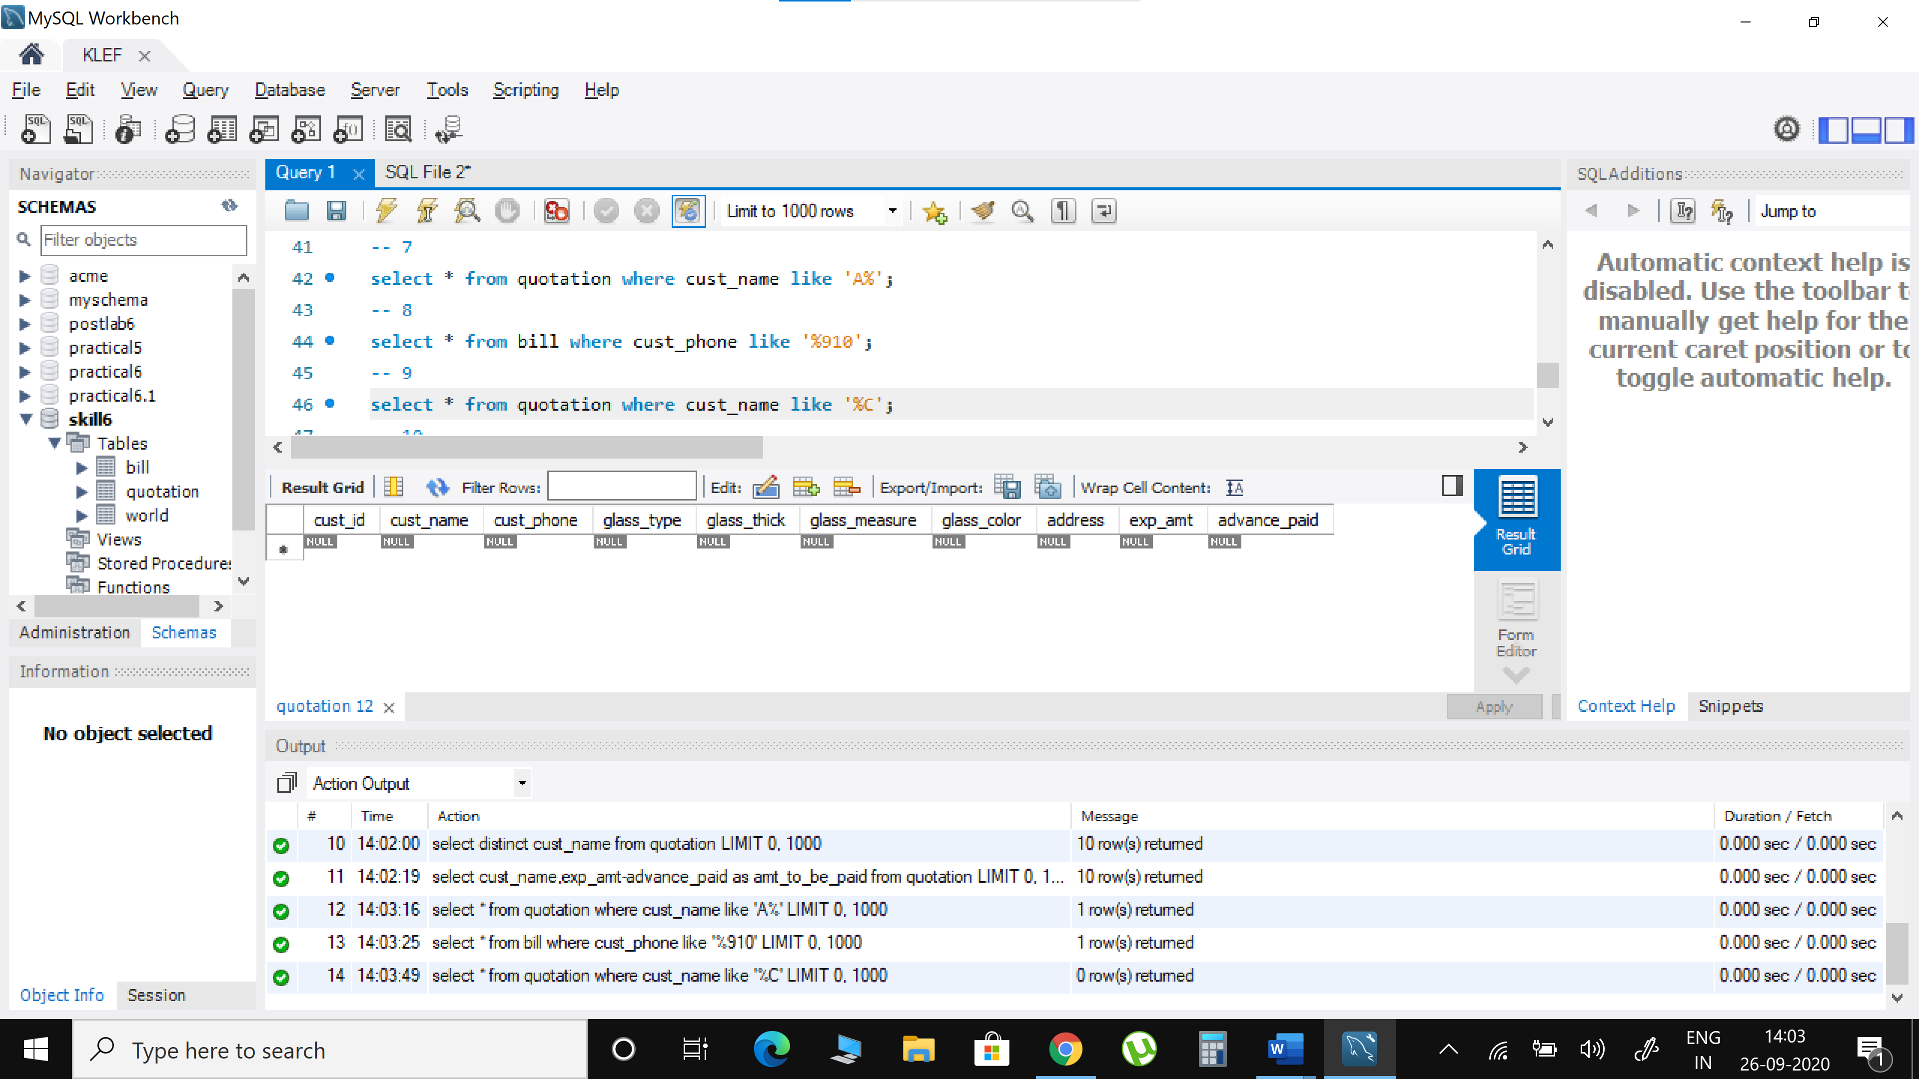

1. Write an SQL query to print details of the customers whose advance paid lies between 1000 and 2000.

select * from quotation where advance_paid between 1000 and 2000;

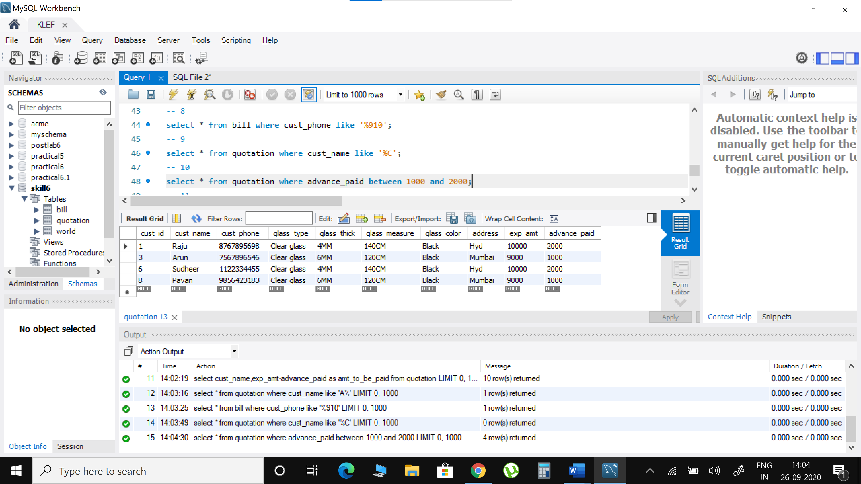

1. Write an SQL query to fetch the list of customers with the same Mode of payment.

select cust_name,mode_pay from bill where mode_pay in

(select distinct mode_pay from bill group by mode_pay having count(mode_pay)>1);

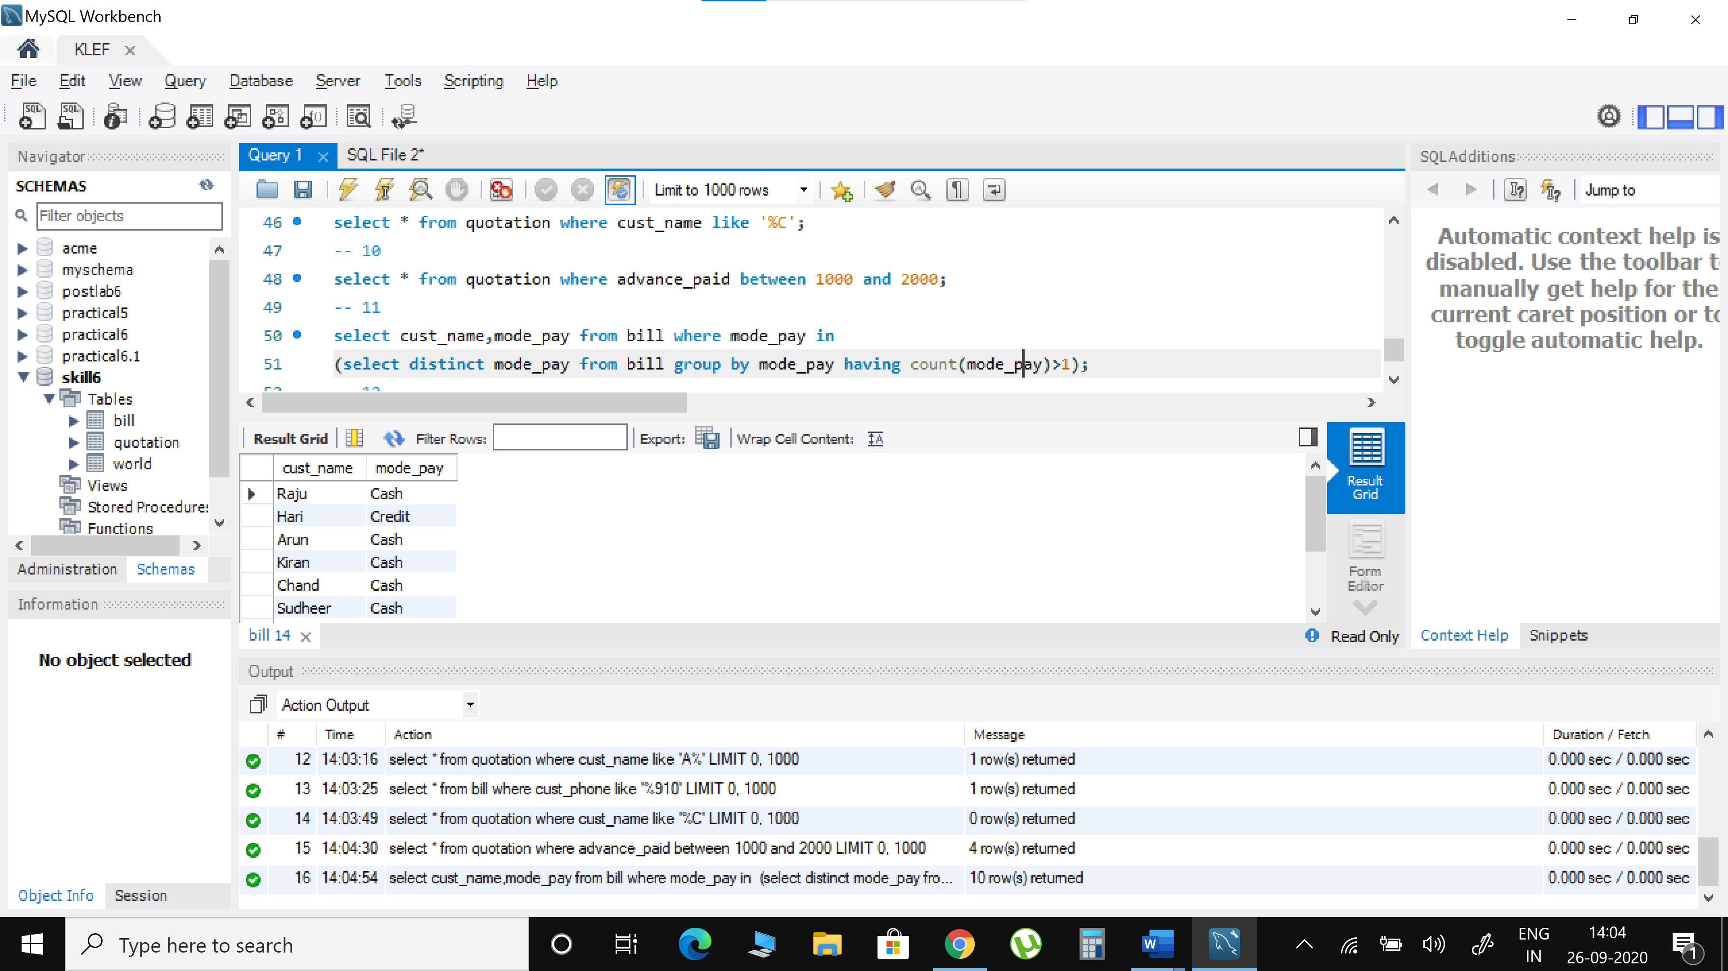

1. Write an SQL query to fetch the Unique records in Quotation and Bill Table

select distinct * from bill;

select distinct * from quotation;

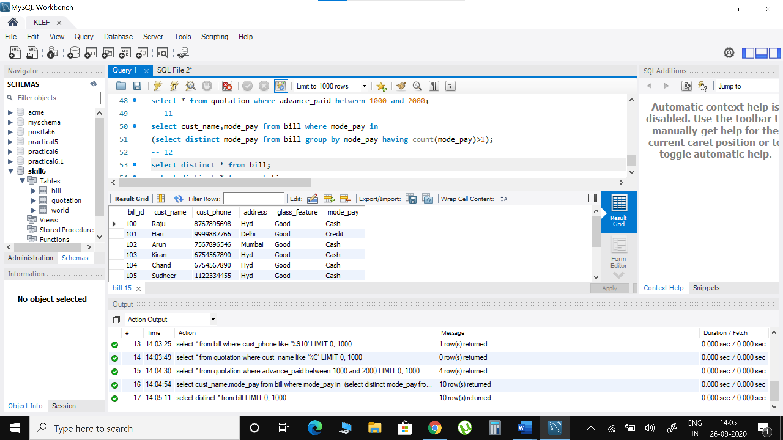 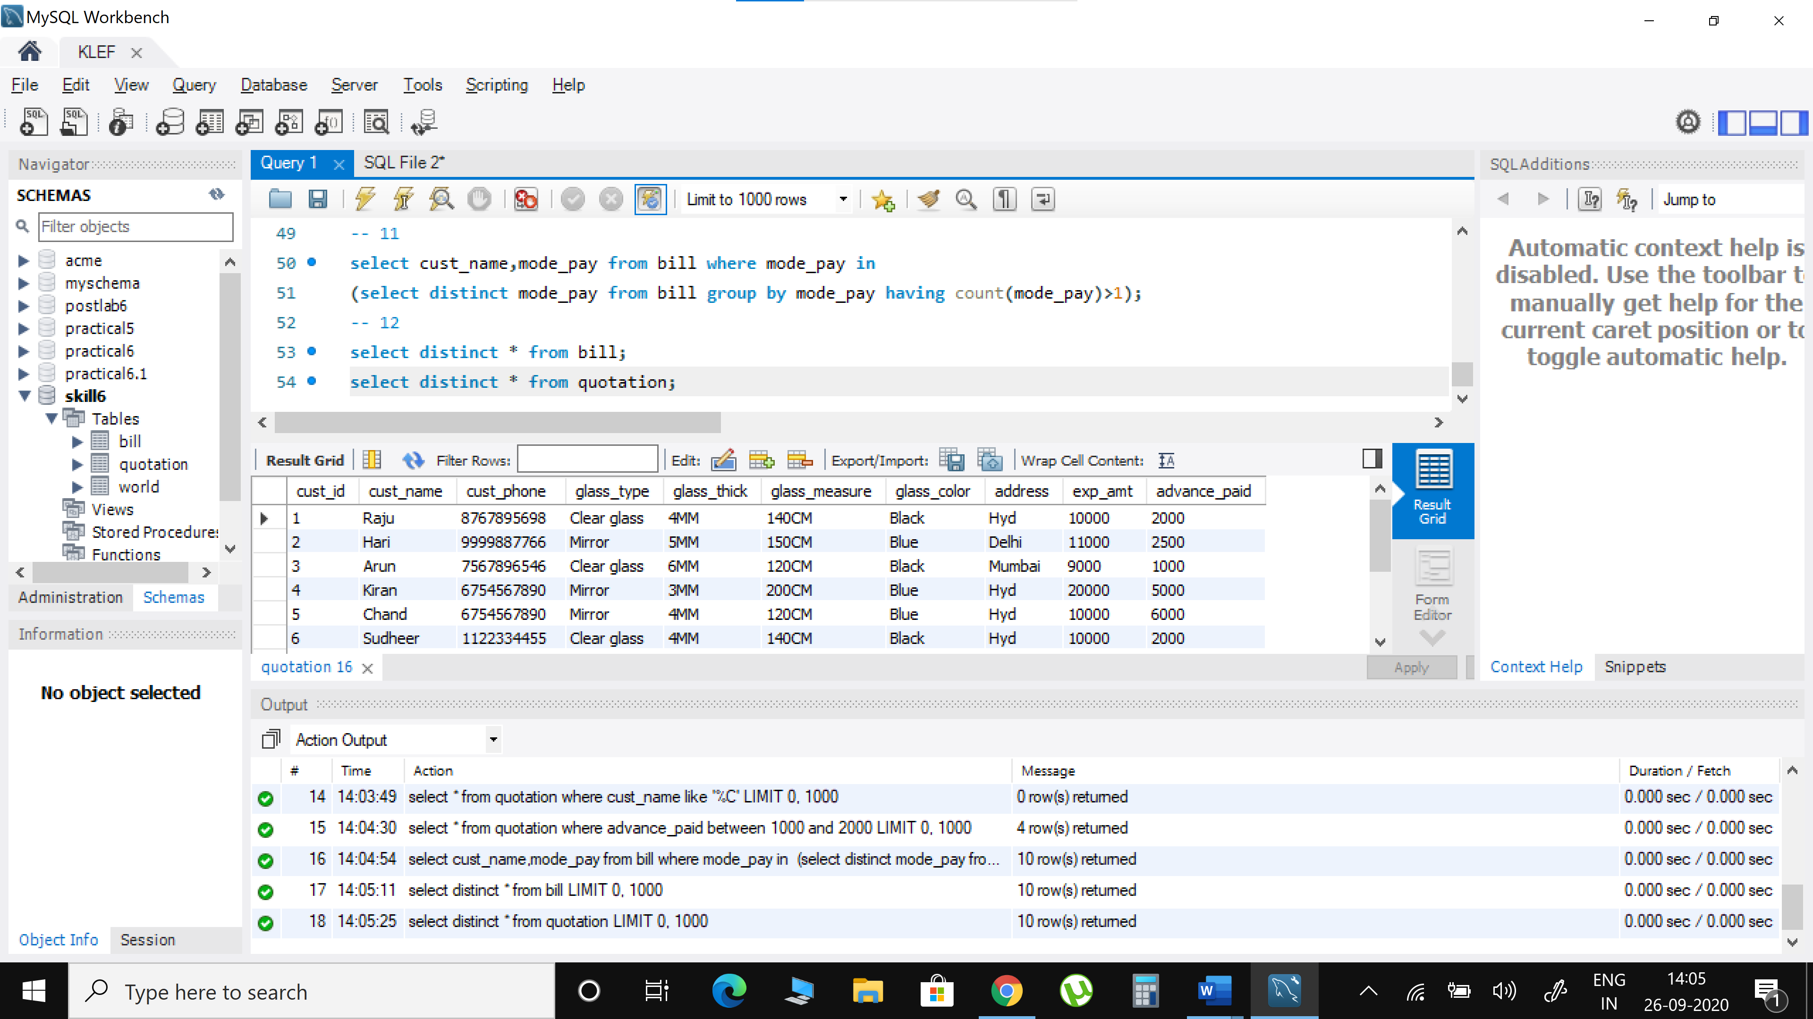

**POSTLAB**

|  |  |  |  |  |
| --- | --- | --- | --- | --- |
| **name** | **continent** | **area** | **population** | **gdp** |
| Afghanistan | Asia | 652230 | 25500100 | 20343000000 |
| Albania | Europe | 28748 | 2831741 | 12960000000 |
| Algeria | Africa | 2381741 | 37100000 | 188681000000 |
| Andorra | Europe | 468 | 78115 | 3712000000 |
| Angola | Africa | 1246700 | 20609294 | 100990000000 |

**create table world (name varchar(50),contient varchar(50),area int,population bigint,gdp bigint);**

**insert into world values('Afghanistan','Asia',652230,2500100,20343000000);**

**insert into world values('Albania','Europe',28748,2831741,12960000000);**

**insert into world values('Algeria','Africa',2381741,37100000,188681000000);**

**insert into world values('Andorra','Europe',468,78115,3712000000);**

**insert into world values('Angola','Africa',1246700,20609294,100990000000);**

1) Show the total population of the world. World (name, continent, area, population, gdp)

select sum(population) from world;

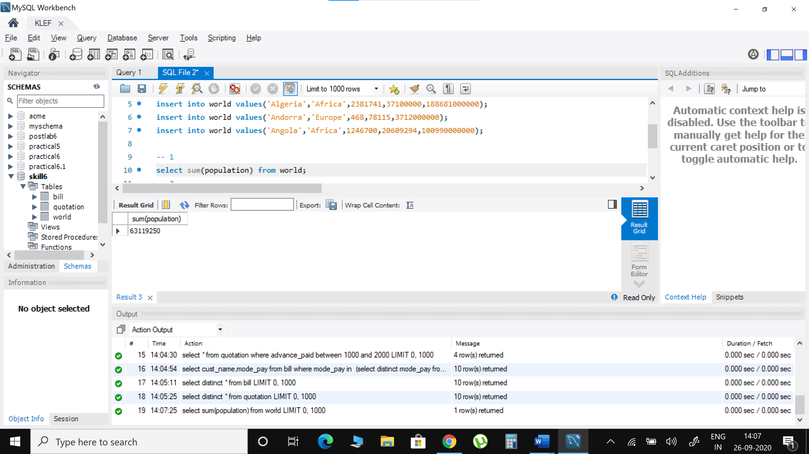

1. For each continent show the continent and number of countries with populations of at least 10 million.

select contient,count(name) from world group by contient,population>10000000;

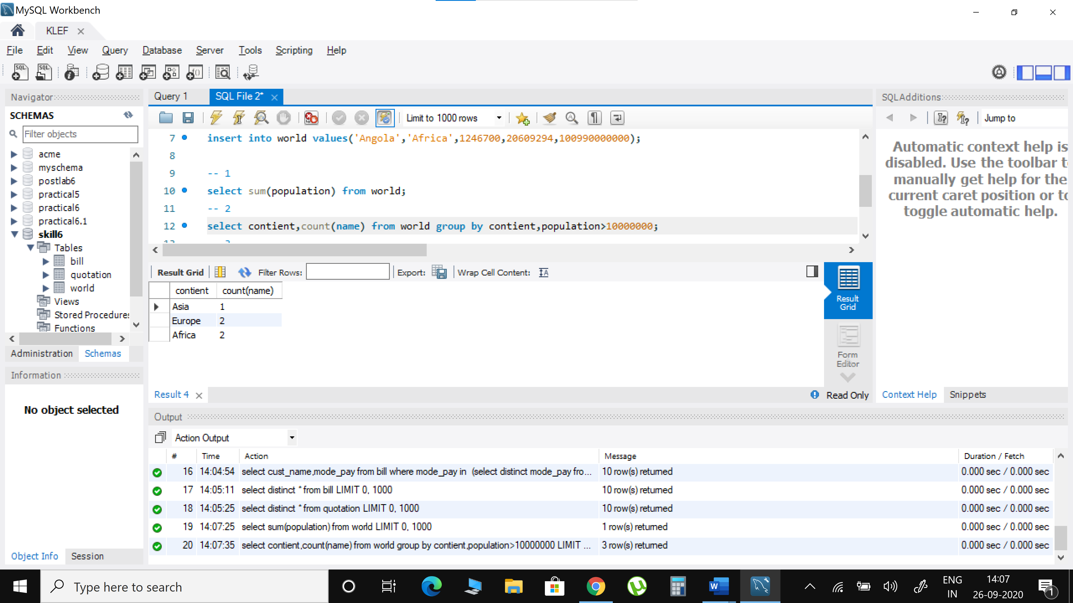

1. List the continents that have a total population of at least 100 million.

select contient,sum(population) from world group by contient having sum(population)>=100000000;

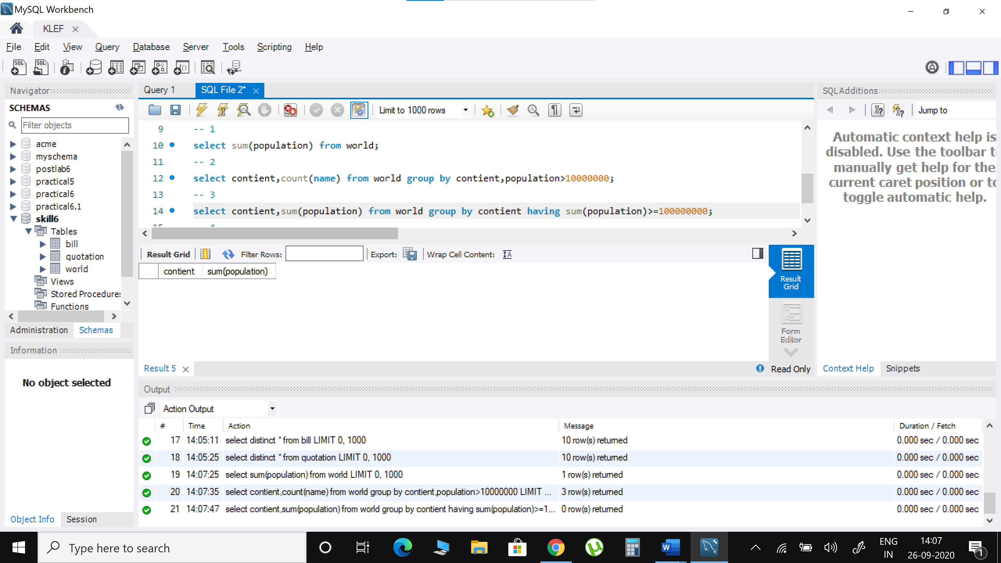

1. Display the list of continents in the world

select distinct contient from world;

